**INDUCTIVE REACTANCE**

**LAB # 03**



**Fall 2021**

**CSE-203L Circuit & Systems-II Lab**

**Submitted by: Ebtihaj Abdullah**

**Registration No. : PWCSE1885**

**Class Section: A**

**“On my honor, as student of University of Engineering and Technology, I have neither given nor received unauthorized assistance on this academic work.”**

**Submitted to:**

**Engr. Faiz Ullah**

**DATED: 18 / NOV/ 2021**

**Department of Computer Systems Engineering**

**University of Engineering and Technology, Peshawar**

**OBJECTIVES:**

* To examine Inductive Reactance
* Relationship of inductance and frequency
* Inductance Reactance versus frequency plot

**INDUCTIVE REACTANCE:**

As the component we are interested in is an inductor, the reactance of an inductor is therefore called “Inductive Reactance”. In other words, an inductors electrical resistance when used in an AC circuit is called Inductive Reactance.

Inductive Reactance which is given the symbol XL, is the property in an AC circuit which opposes the change in the current. In Capacitors in AC Circuits, we s**ee** that in a purely capacitive circuit, the current IC “LEADS” the voltage by 90o. In a purely inductive AC circuit the exact opposite is true, the current IL “LAGS” the applied voltage by 90o, or (π/2 rads).

AC INDUCTOR CIRCUIT

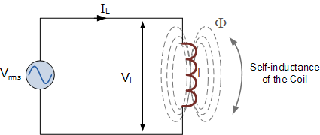

In the purely inductive circuit above, the inductor is connected directly across the AC supply voltage. As the supply voltage increases and decreases with the frequency, the self-induced back emf also increases and decreases in the coil with respect to this change.

We know that this self-induced emf is directly proportional to the rate of change of the current through the coil and is at its greatest as the supply voltage crosses over from its positive half cycle to its negative half cycle or vice versa at points, 0o and 180o along the sine wave.

Consequently, the minimum rate of change of the voltage occurs when the AC sine wave crosses over at its maximum or minimum peak voltage level. At these positions in the cycle the maximum or minimum currents are flowing through the inductor circuit and this is shown below.

**AC INDUCTOR PHASOR DIAGRAM**

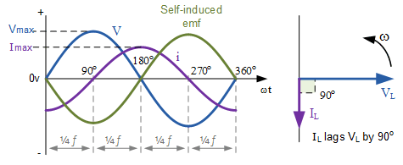

These voltage and current waveforms show that for a purely inductive circuit the current lags the voltage by 90o. Likewise, we can also say that the voltage leads the current by 90o. Either way the general expression is that the current lags as shown in the vector diagram. Here the current vector and the voltage vector are shown displaced by 90o. The current lags the voltage.

We can also write this statement as, VL = 0o and IL = -90o with respect to the voltage, VL. If the voltage waveform is classed as a sine wave then the current, IL can be classed as a negative cosine and we can define the value of the current at any point in time as being:

instantaneous inductor current

Where: ω is in radians per second and t is in seconds.

Since the current always lags the voltage by 90o in a purely inductive circuit, we can find the phase of the current by knowing the phase of the voltage or vice versa. So if we know the value of VL, then IL must lag by 90o. Likewise, if we know the value of IL then VL must therefore lead by 90o. Then this ratio of voltage to current in an inductive circuit will produce an equation that defines the Inductive Reactance, XL of the coil.

**INDUCTIVE REACTANCE**

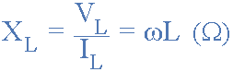

We can rewrite the above equation for inductive reactance into a more familiar form that uses the ordinary frequency of the supply instead of the angular frequency in radians, ω and this is given as:

inductive reactance equation

Where: ƒ is the Frequency and L is the Inductance of the Coil and 2πƒ = ω.

From the above equation for inductive reactance, it can be seen that if either of the Frequency or Inductance was increased the overall inductive reactance value would also increase. As the frequency approaches infinity the inductors reactance would also increase to infinity acting like an open circuit.

However, as the frequency approaches zero or DC, the inductors reactance would decrease to zero, acting like a short circuit. This means then that inductive reactance is “proportional” to frequency.

In other words, inductive reactance increases with frequency resulting in XL being small at low frequencies and XL being high at high frequencies and this demonstrated in the following graph:

**INDUCTIVE REACTANCE AGAINST FREQUENCY**

|  |  |
| --- | --- |
| reactance against frequency | The slope shows that the “Inductive Reactance” of an inductor increases as the supply frequency across it increases.  Therefore Inductive Reactance is proportional to frequency giving: ( XL α ƒ ) |

Then we can see that at DC an inductor has zero reactance (short-circuit), at high frequencies an inductor has infinite reactance (open-circuit).

**EXPERIMENT:**

The magnitude of inductive reactance may be determined experimentally by feeding an inductor a knowncurrent, measuring the resulting voltage, and dividing the two, following Ohm’s Law. This process may berepeated across a range of frequencies in order to obtain a plot of inductive reactance versus frequency.

An AC current source may be approximated by placing a large resistance in series with an AC voltage, theresistance being considerably larger than the maximum reactance expected.

**EQUIPMENT:**

1. Oscilloscope DMM
2. AC Function Generator

**COMPONENTS:**

1. 1mH Inductor
2. 10mH Inductor
3. 10kΩ Resistor

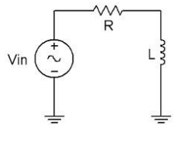

**PROCEDURE:**

**1. Current Source**

Using Figure 1 with Vin=10 Vp-p and R=10 kΩ, and assuming that the reactance of the inductor is much smaller than 10k and can be ignored, determine the circulating current using measured component values and record in Table 1.

**2. Measuring Reactance**

Build the circuit of Figure 1 using R=10 kΩ, and L=10 mH. Place one probe across the generator and another across the inductor. Set the generator to a 1000 Hz sine wave and 10Vp-p. Make sure that the Bandwidth Limit of the oscilloscope is engaged for both channels. This will reduce the signal noise and make for more accurate readings.

3. Calculate the theoretical value of XL using the measured inductor value and record in Table2.

4. Record the peak-to-peak inductor voltage and record in Table 2.

5. Using the source current from Table 1 and the measured inductor voltage, determine the experimental reactance and record it in Table 2. Also compute and record the deviation.

6. Repeat steps three through five for the remaining frequencies of Table 2.

7. Replace the 10 mH inductor with the 1mH unit and repeat steps two through six, recording results in Table 3.

8. Using the data of Tables 2 and 3, create plots of inductive reactance versus frequency.

**OBSERVATIONS:**

**V(p-p)  = 10V**

**For 10mH**

|  |  |
| --- | --- |
| **Is(p-p)** | 1 mA |

|  |  |  |  |  |
| --- | --- | --- | --- | --- |
| **Frequency** | **XL(TH)** | **VL(p-p)** | **XL(EXP)** | **%DIFF** |
| **1k** | 62.8 H | 60 mV | 60 H | 4.45% |
| **2k** | 125.6 H | 130 mV | 130 H | 3.50% |
| **3k** | 188.4 H | 200 mV | 200 H | 6.17% |
| **4k** | 251.2 H | 260 mV | 260 H | 3.58% |
| **5k** | 314 H | 320 mV | 320 H | 1.91% |
| **6k** | 376.8 H | 380 mV | 380 H | 1.06% |
| **8k** | 502.4 H | 520 mV | 520 H | 3.51% |
| **10k** | 628 H | 640 mV | 640 H | 1.9% |

For 1k Hz,10mH

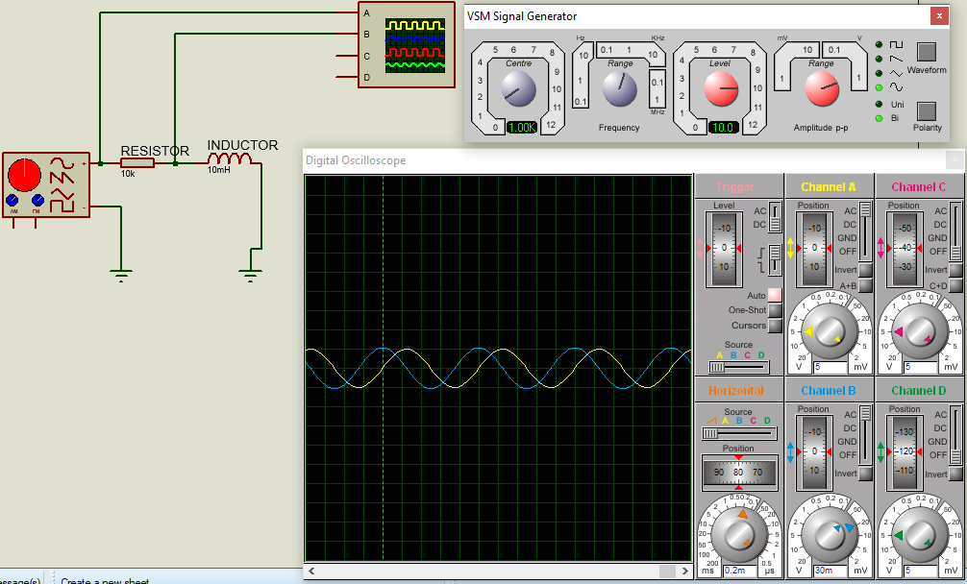

For 2k Hz,10mH

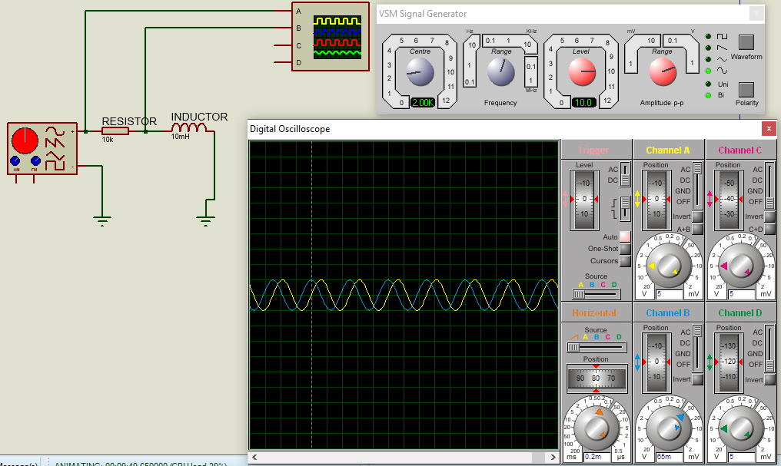

For 3k Hz,10mH

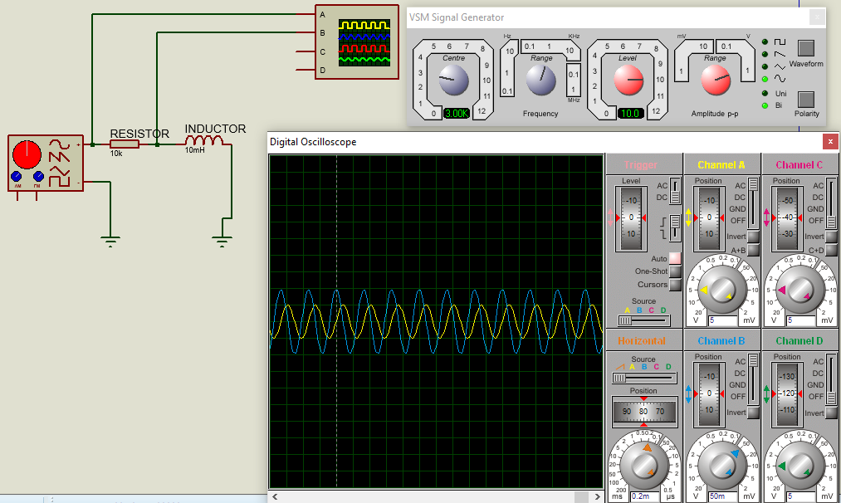

For 4k Hz,10mH

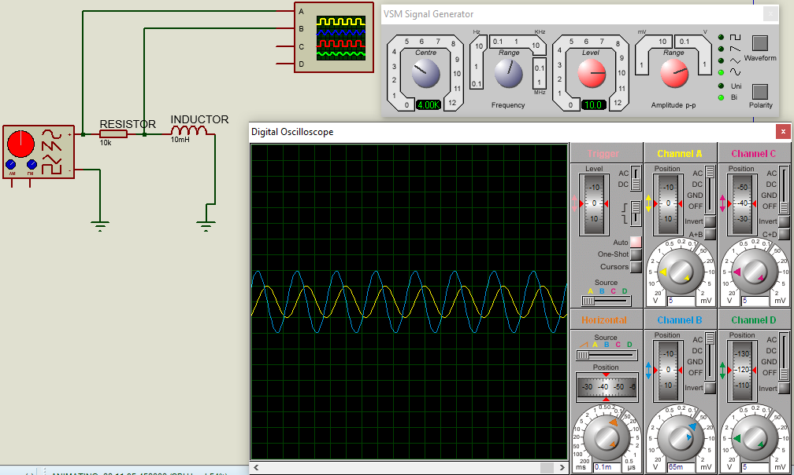

For 5k Hz,10mH

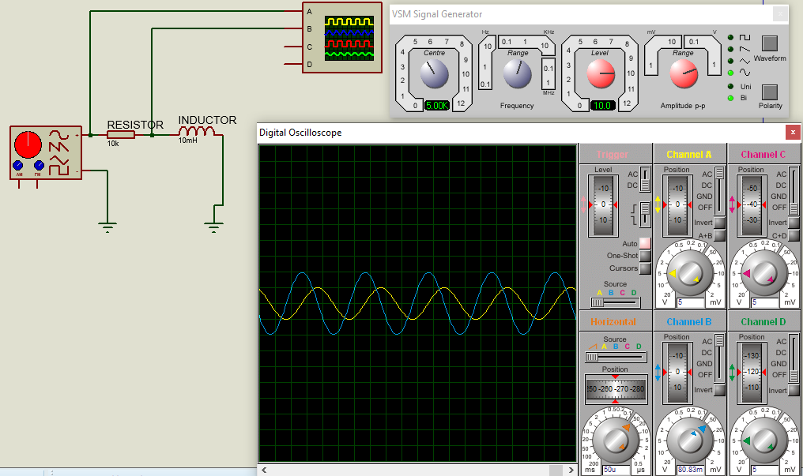

For 6k Hz,10mH

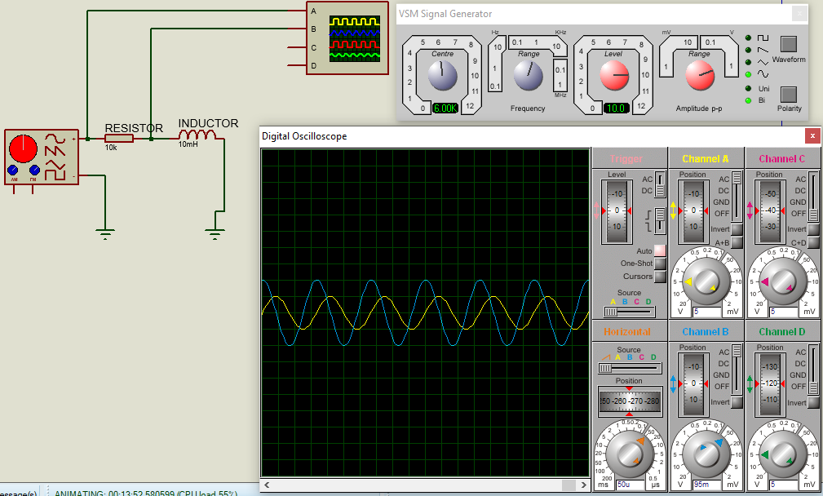

For 8k Hz,10mH

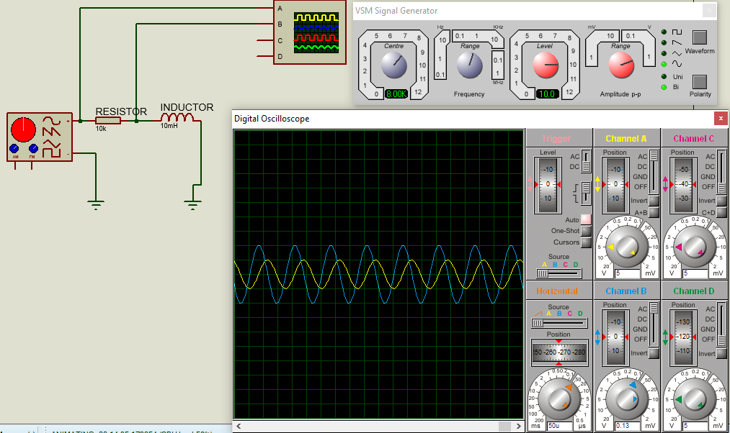

For 10k Hz,10mH

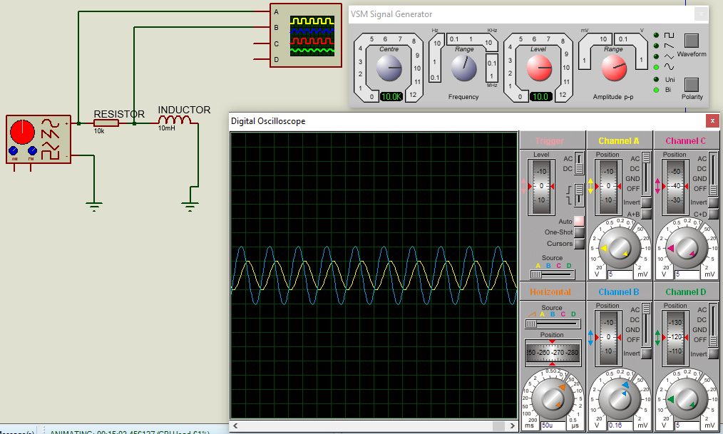

**For 1mH**

|  |  |
| --- | --- |
| **Is(p-p)** | 1 mA |

|  |  |  |  |  |
| --- | --- | --- | --- | --- |
| **Frequency** | **XL(TH)** | **VL(p-p)** | **XL(EXP)** | **%DIFF** |
| **10k** | 62.8 | 64 mV | 64H | 1.91% |
| **20k** | 125.6 | 128 mV | 128H | 1.91% |
| **30k** | 188.4 | 192 mV | 192H | 1.91% |
| **40k** | 251.2 | 255 mV | 255H | 1.51% |
| **50k** | 314 | 320 mV | 320H | 1.91% |
| **60k** | 376.8 | 380 mV | 380H | 0.84% |
| **80k** | 502.4 | 504 mV | 504H | 0.31% |
| **100k** | 628 | 640 mV | 640H | 1.91% |

For 10k Hz, 1mH

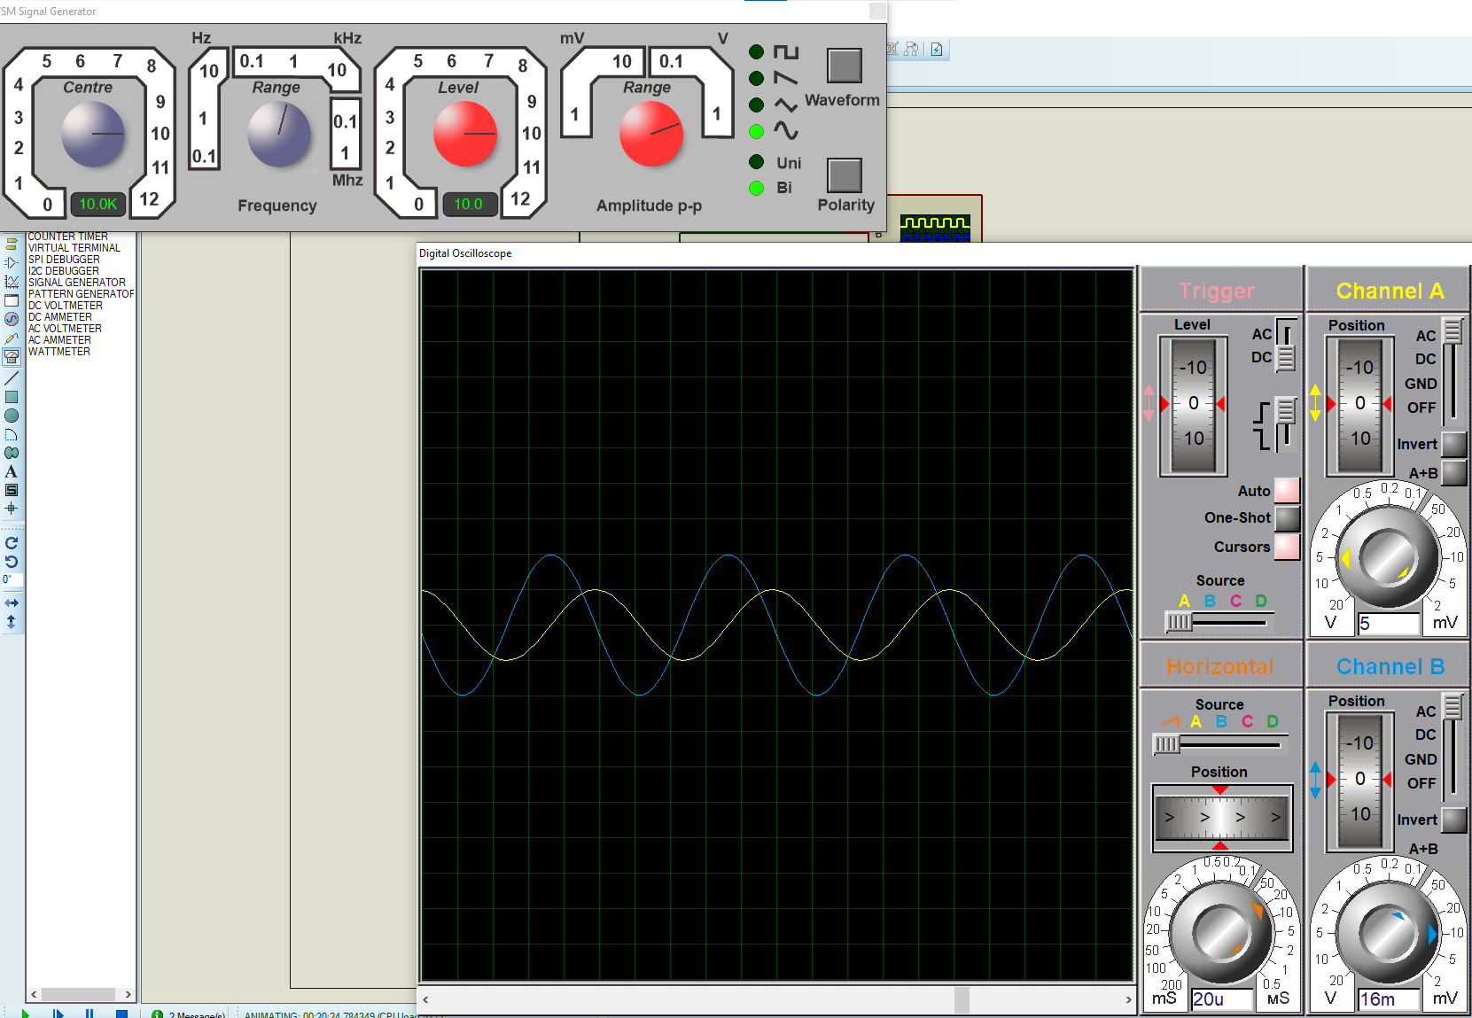

For 20k Hz, 1mH

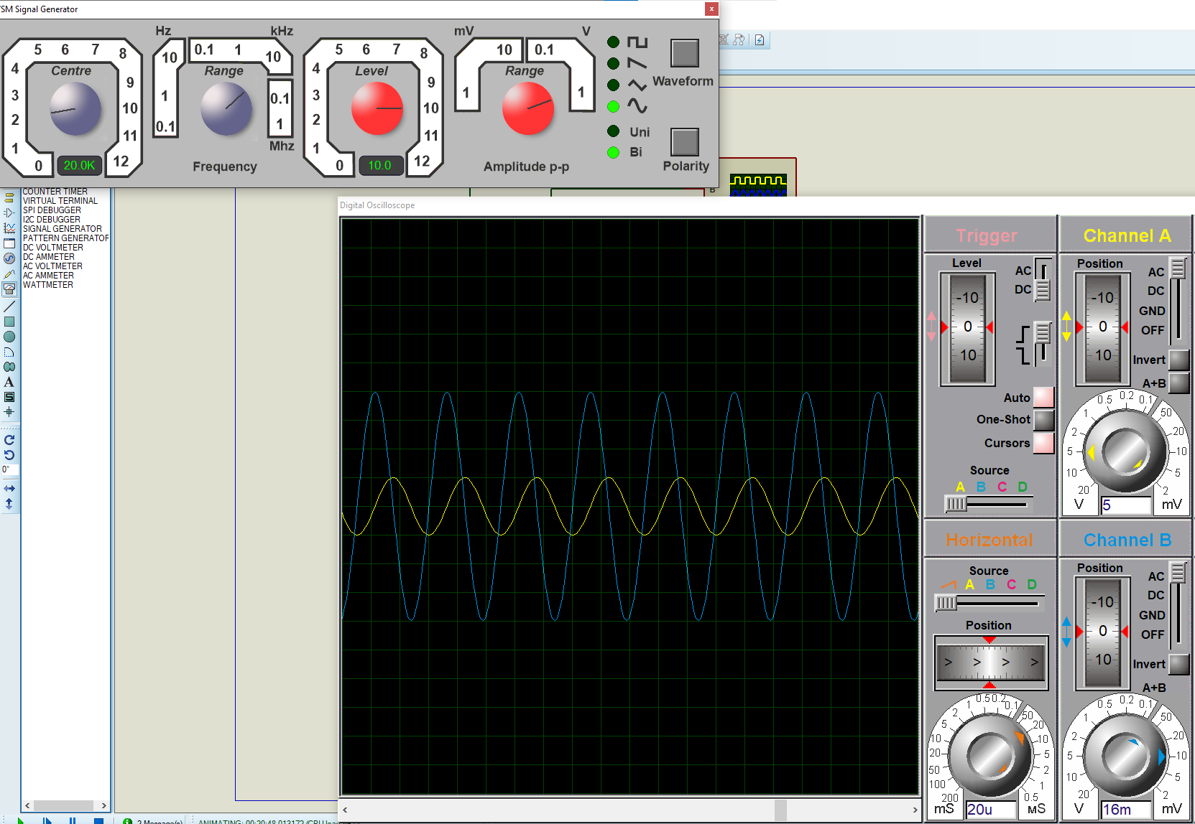

For 30k Hz, 1mH

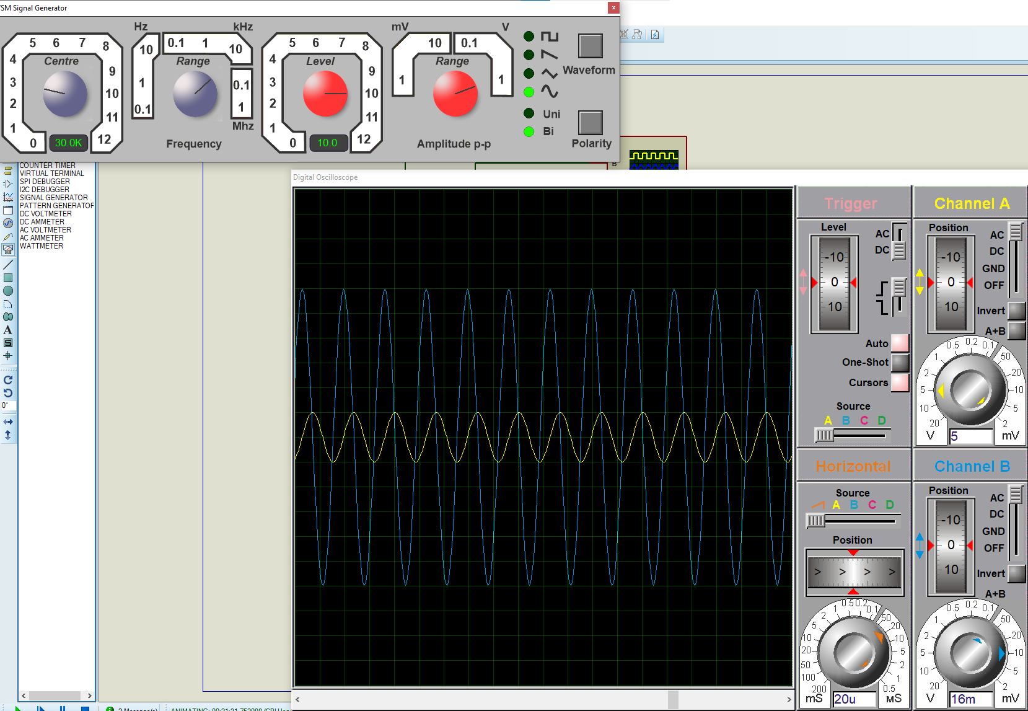

For 40k Hz, 1mH

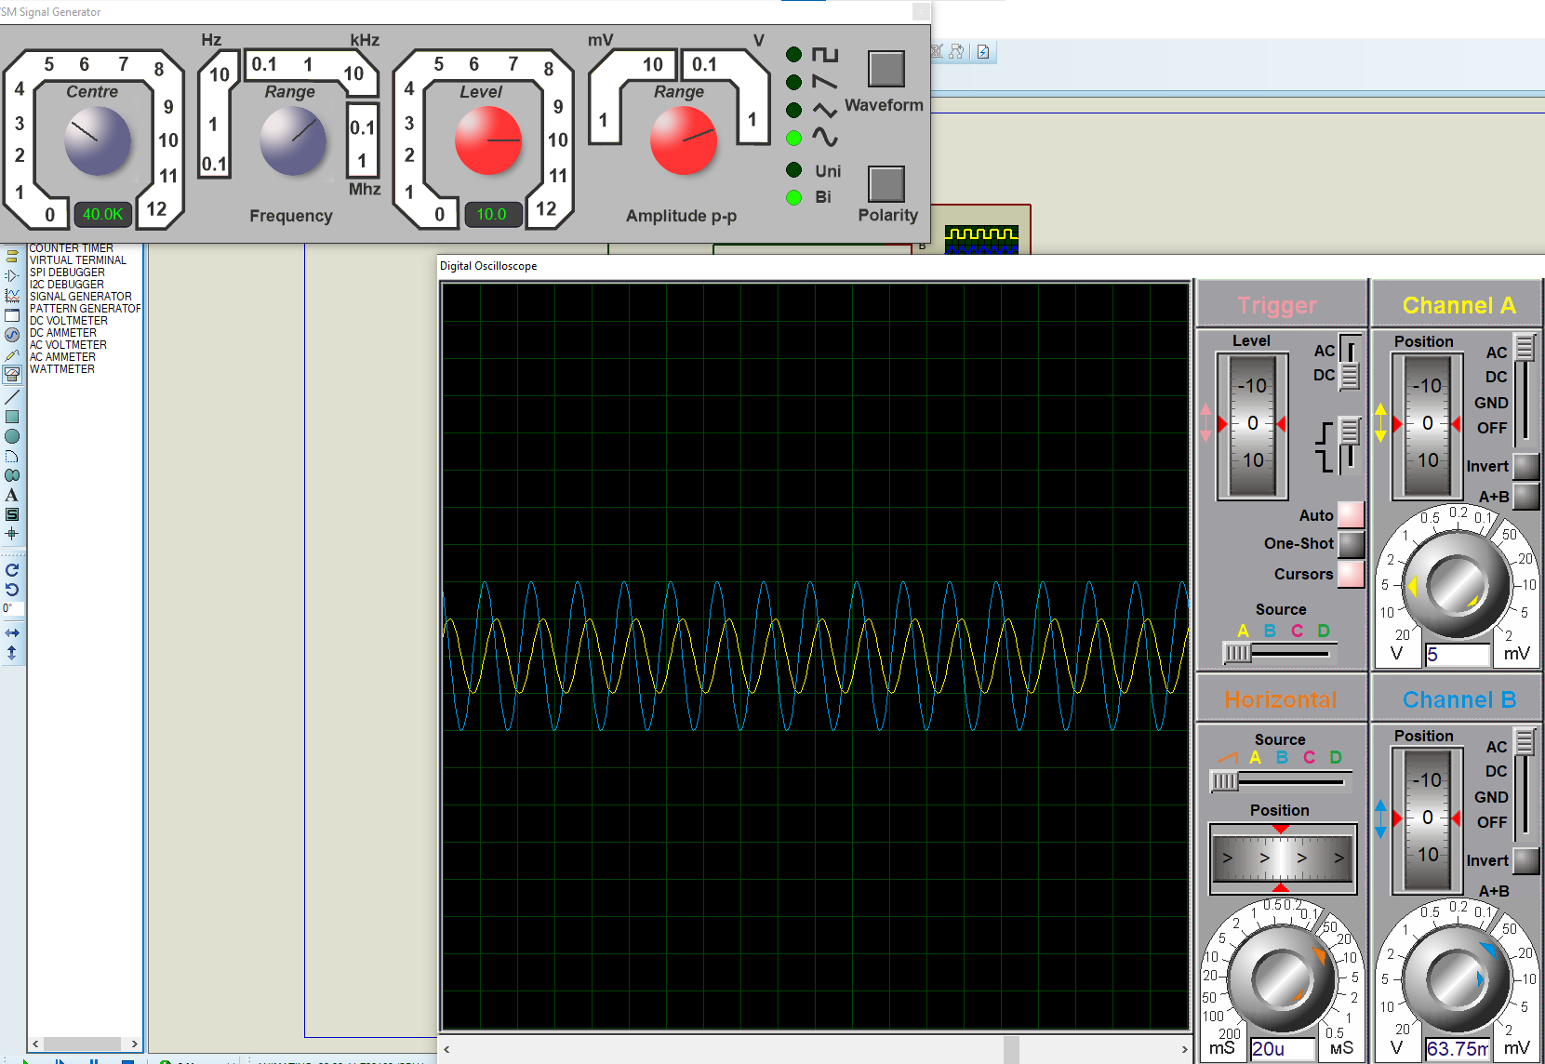

For 50k Hz, 1mH

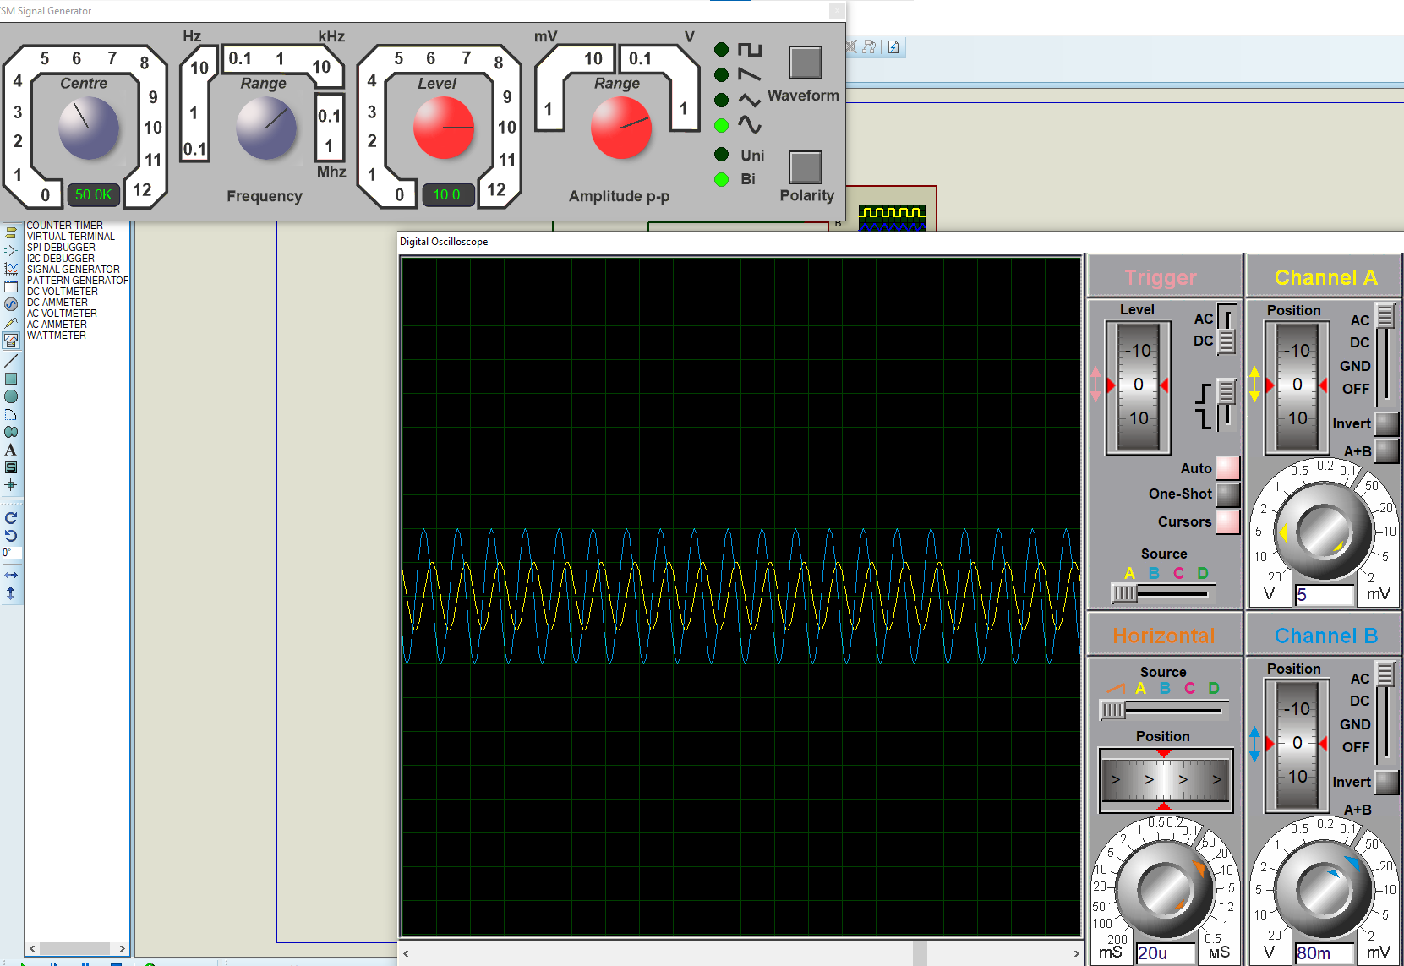

For 60k Hz, 1mH

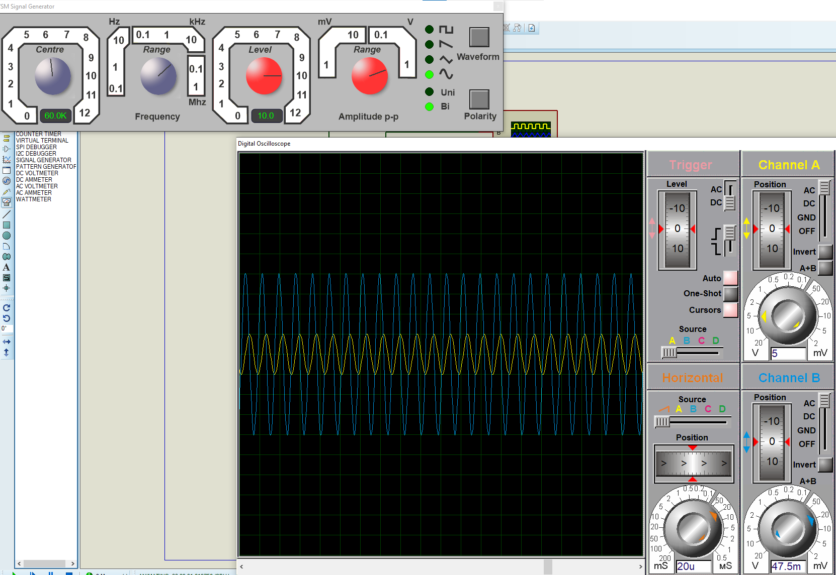

For 80k Hz, 1mH

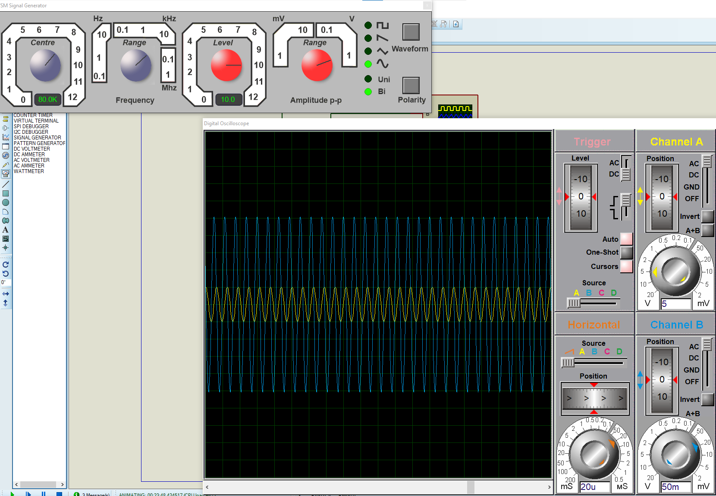

For 100k Hz, 1mH

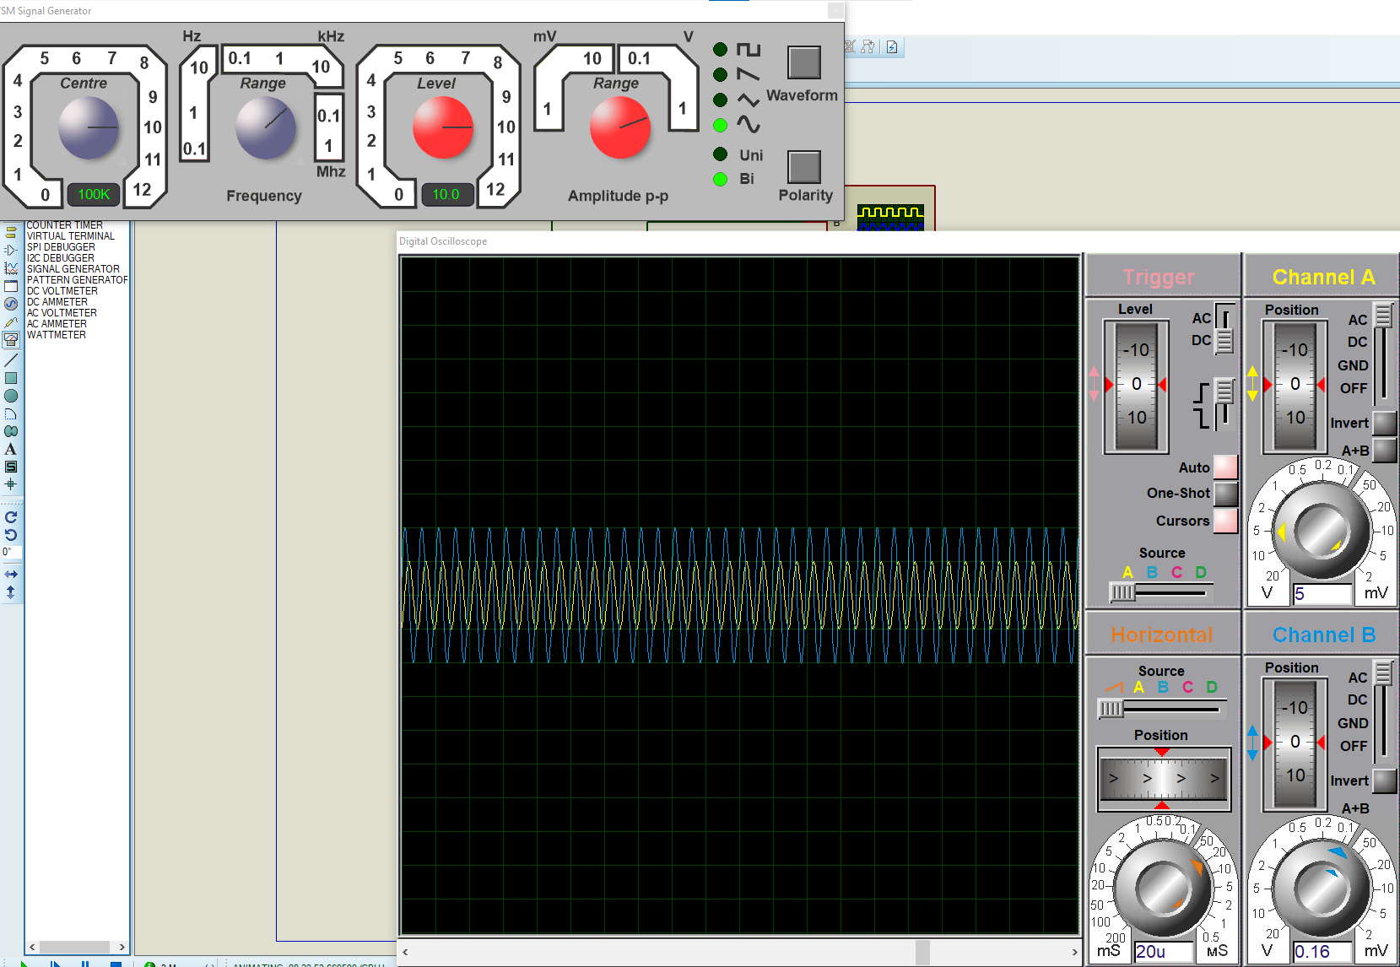

**QUESTIONS:**

1. What is the relationship between inductive reactance and frequency?
2. What is the relationship between inductive reactance and inductance?
3. If the 10mH trial had been repeated with frequencies 10 times higher than those in Table 2, what effect would that have on the experiment?
4. Do the coil resistances have any effect on the plots?

**ANSWER#1**

As we know that,



We can rewrite the above equation for inductive reactance into a more familiar form that uses the ordinary frequency of the supply instead of the angular frequency in radians, ω and this is given as:

inductive reactance equation

Where: ƒ is the Frequency and L is the Inductance of the Coil and 2πƒ = ω.

From the above equation for inductive reactance, it can be seen that if either of the Frequency or Inductance was increased the overall inductive reactance value would also increase. As the frequency approaches infinity the inductors reactance would also increase to infinity acting like an open circuit.

However, as the frequency approaches zero or DC, the inductors reactance would decrease to zero, acting like a short circuit. This means then that inductive reactance is **“proportional”** to frequency.

In other words, **inductive reactance increases with frequency resulting in XL being small at low frequencies and XL being high at high frequencies** and this demonstrated in the following graph:

**INDUCTIVE REACTANCE AGAINST FREQUENCY**

|  |  |
| --- | --- |
| reactance against frequency | The slope shows that the “Inductive Reactance” of an inductor increases as the supply frequency across it increases.  Therefore Inductive Reactance is proportional to frequency giving: ( XL α ƒ ) |

**ANSWER#2**

**INDUCTANCE:**

Inductance is the ability to create a voltage within a conductor or a nearby conductor by changing the current flow in that first conductor.

***The larger the inductance the greater the voltage induced per change in current. Inductive reactance is an opposit. The higher the inductive reactance, the larger the resistance to a change in current is.ion to a change in current***

The two terms are related closely, but are not the same.

Generally,

***the larger the inductance the more inductive reactance a circuit element has.***

This makes sense since a larger induced voltage per change in current (larger inductance) opposes that change in current (inductive reactance) more than a smaller induced voltage per change in current. In other words, a smaller change in the current will induce equal voltage to a larger change in current if inductance is larger. With greater inductance the change in current required to induce a particular voltage is smaller.

**ANSWER#3**

As we know that inductive reactance is directly proportional to the frequency.

***The greater the frequency, the greater the inductive reactance.***

So, if we increase the frequency 10 times, the reactance will increase proportionally by ten times.

Same is the case for 10mH inductor, if we increase the frequency 10 times, the reactance will increase by 10 times. The trend in graph plot will remain the same as that of lower frequencies.

**ANSWER#4**

The four factors that affect the inductance of a coil are;

1. Coil Area
2. Coil length
3. Coil material
4. Coil turns

In real life an inductor consists of a coil of wire (with or without a laminated iron core). So a real inductor has both resistance and inductance. If you double the inductance by increasing the length of wire on the coil, then the resistance will increase . And the inductance is doubled by adding more turns to the coil. However, the case may be different for pure and real-life inductors.

So, plot doesn’t changes.